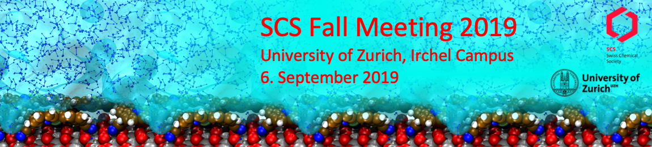

Event Name | SCS Fall Meeting 2019
Date | Fri, 06.09.2019
Location | University of Zürich, Irchel Campus, Winterthurerstrasse 190, 8057 Zürich
Focus/Topic | The SCS Fall Meeting is one of the largest annual scientific events held in Switzerland providing a fantastic and diverse program with contributions from academic and industrial research in all fields of chemistry.  The Scientific Program will offer invited and contributed lectures as well as poster presentations in eight topical sessions.
Audience | Up to 1’000 Participants (70% students, 20% academics, 10% industrials)
Website | https://scg.ch/fallmeeting/2019
Total budget | CHF 120’000
Chairs | Prof. Roger Alberto, University of Zurich, ariel@chem.uzh.ch  Dr. Hans Peter Lüthi, ETH Zurich, luethi@scg.ch
Sponsoring / Collaboration | Event Partner or Sponsor of one of the eight Sessions: CHF 5’000  - Logo on the website and all symposium documents incl. CHIMIA 7-8/2019  - 2 registrations for free (incl. coffee and lunch)  - 30min slot for a scientific talk in the session sponsored  - Invitation of 1 company delegate to the Symposium Dinner on 05.09.2019  - Exhibitor booth  Sponsoring possibilities on demand: CHF 1’000 … 5’000
Exhibition | Exhibitor Plus: CHF 2’500. Preferred booth no:  - Booth 9m²  - Logo on the website and all symposium documents incl. CHIMIA 7-8/2019  - 2 registrations for free (incl. coffee and lunch)  - 1 company report in CHIMA or 0.5 page advertisement in CHIMIA  - Invitation of 1 person to the symposium dinner on Thu, 05.09.2019  Exhibitor Standard: CHF 1’000. Preferred booth no:  - Booth 9m²  - Logo on the website and all symposium documents incl. CHIMIA 7-8/2019  - 2 registrations for free (incl. coffee and lunch)
CHIMIA | Services partially included in Exhibitors Plus package:  Advertisement 0.5 page  Company report (1 page)  Additional advertisement: see CHIMIA flyer 2019. Special rates and discount for SCS corporate members
Booking | Please tick the box above and send form to info@scg.ch  David Spichiger, Executive Director, +41 31 306 92 91,
Invoice address:
Contact person | Name:  Email:
Date, location | 31.01.2019,

Floor Plan SCS Fall Meeting 2019

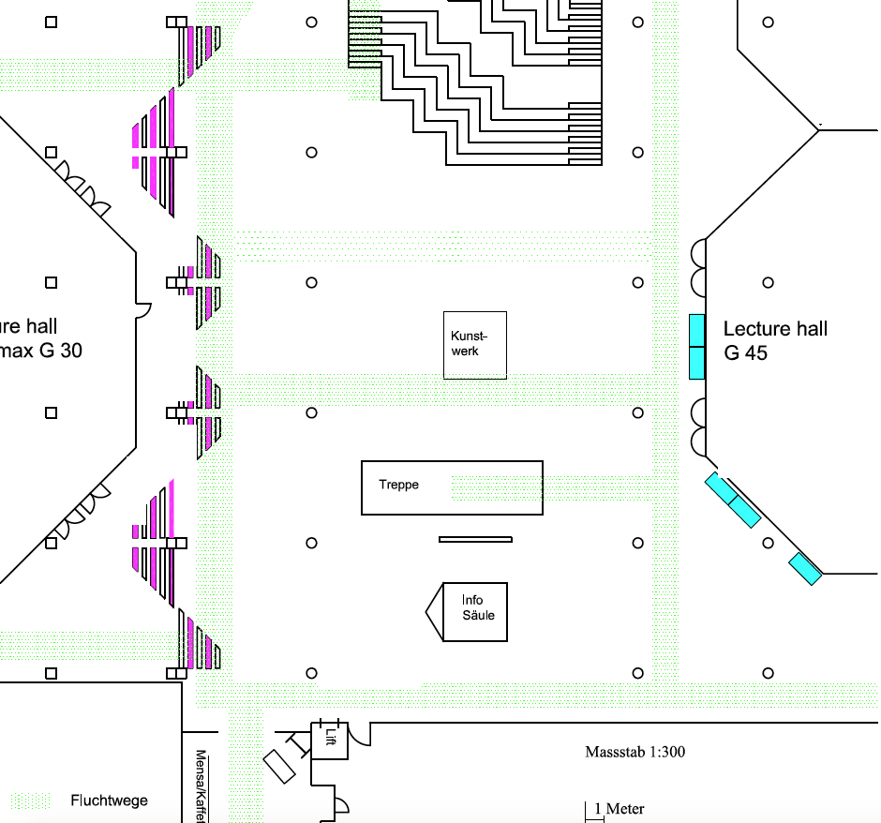
SCNAT
Info
SCG
13
14
15
16
17
SCS Fall Meeting 2019
Lecture Hall G30
SCS Fall Meeting 2019
Lecture Hall G45
19
18
22
21
20
7
12
11
10
7
8
9
3
2
1
4
7
8
9
Haupteingang
10
6
5
11
12

